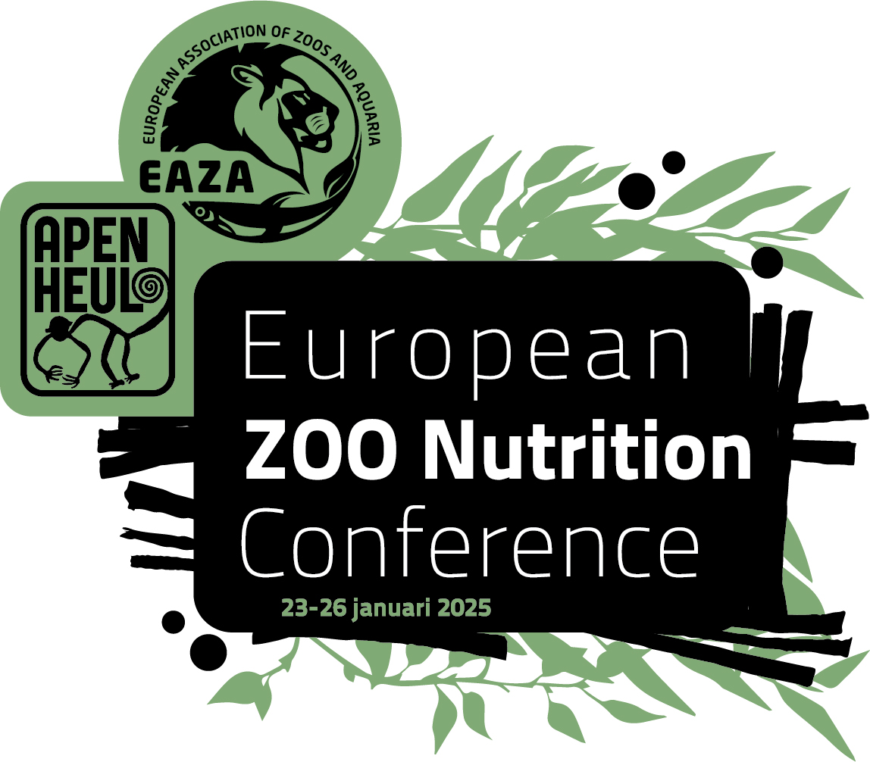

Abstract submission form

- Submissions are welcomed from both practitioners and researchers
- Please use the template as given on the next page, by writing your title, author line, affiliations, abstracts and keywords directly into this document
- Please indicate if your submission is for an oral presentation (15 minutes) or poster
- Abstracts should be no more than 500 words and written in English
- Deadline for submission is 31st of August 2024. Based on past experience, the deadline might be postponed, but priority for oral presentations will be given to submissions arriving prior to the original deadline
- All delegates, including speakers, must register for the conference.

Please submit your abstracts to the EAZA Nutrition Group (Marcus Clauss) by mclauss@vetclinics.uzh.ch before 31st of August 2024, with ‘EZNC23 - [Poster/presentation] - Abstract - [Name]’ in the subject line.

Please tick which type of presentation you would like give

Poster presentation Oral presentation (15 min)

Never give up: changing giant anteaters (Myrmecophaga tridactyla) to a new, complete diet at Zurich Zoo
Jessica Gull¹, Thomas Rothlin², Marcus Clauss¹ & Jean-Michel Hatt¹

¹Clinic for Zoo Animals, Exotic Pets and Wildlife, Vetsuisse Faculty, University of Zurich; ²Zoo Zurich, Switzerland

Diets fed to captive anteaters have historically been complex and time-consuming to prepare. Recently, complete feeds for anteaters have been produced commercially. At the last European Zoo Nutrition Conference, we reported how attempts to change anteaters to a new product had failed at Zurich Zoo. At that time, a pinch of the complete diet that was formulated as granules was mixed into the traditional diet. The animals thereafter either completely refused the food or licked the traditional diet around the granules. To increase the acceptability of the formulated diet the granules were ground. This resulted in a complete refusal of food even if it contained just a tiny amount of the new diet. During the trial a weight loss of 10% was tolerated. Due to lactating females and increased aggressive behaviour towards conspecifics and keepers, it was decided to stop the trial after four weeks. Difficulties translocating anteaters to zoos that feed a formulated diet, meeting nutritional requirements, lower hygiene risk compared to diets containing minced meat and because other zoos reported their successful diet switch, it was decided to try the diet change again. This time, another formulated diet was used that comes in powder form. The approach for the diet change was the same, but the new diet was never completely refused. After four days the whole feed including the pinch of the new diet were eaten and the amount of the new diet could be increased stepwise with interruptions of a few days. The animals are fed twice daily 250g of the powder diluted with water. Sometimes the food was not touched until the afternoon or they stopped eating for one or two days. The diet change was completed in four months. For enrichment, insects, fruits, yoghurt and raw eggs are still offered, but only after the complete diet is eaten (otherwise animals eat only the enrichment food). With the new diet, keepers save approximately 30 min of working time per day. Faecal consistency did not change. However a considerable weight loss was observed: before the diet change all three animals weighed 51 kg, 12 days after the diet change the male weighed 49 kg (- 4%) and the two females weighed 45 kg (- 12%). One and a half year after the diet change, the male weights 48 kg (- 6%), one female weights 42 kg (- 17%) and the other female weights 39kg (- 23.5%). From palpation the animals seem considerably thinner. Nevertheless the weight loss was considered acceptable because the body mass is still above the published values for adults in the wild (male 31 to 39 kg, female 29 - 37 kg). The main reason for success of the new diet is considered to be the powder form, whereas the previous product came in granules, and during the second attempt to change the diet a greater weight loss was tolerated since the offspring was almost weaned. Although no negative effects on animal health are noticed so far, potential positive effects can only be assessed after prolonged periods of time.

KEYWORDS: Anteater, complete feed, diet switch

